**Red and Green**

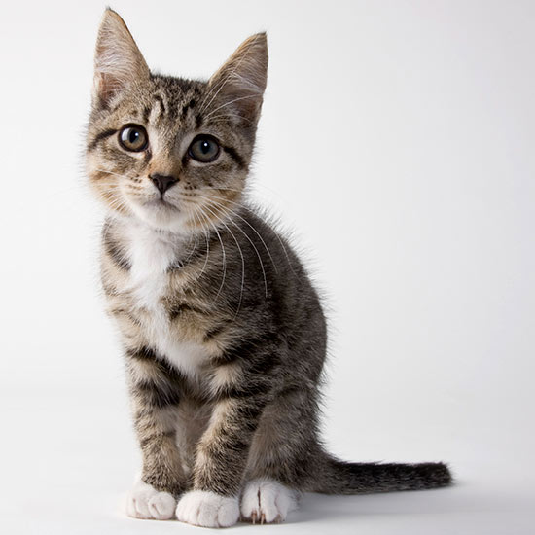

**Model: 878**

**Can upgrade: 878 is ok!**

**comment: Can be improved!**